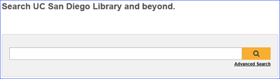
- Searching
The Melvyl search box (or a link to the search box) is located on your campus library’s web site.
  - Advanced Search
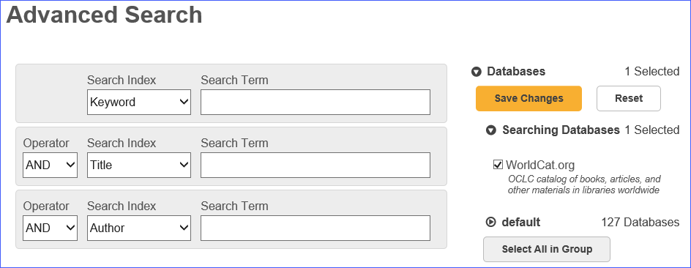
Links to Advanced Search are available on the Melvyl home page and on all search screens. On the Advanced Search screen, you can limit
your search to specific databases to improve the
accuracy of your search results. To clear all
databases (on by default), scroll to the bottom
of the screen & click the Select All in Group
button. Then select the databases you want to
search and click the Save Changes button at
the top of the list of databases.

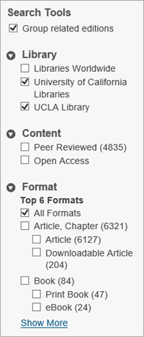
- Refining Your Search
After a search, results can be refined with faceted browsing. To do this, select an option under Search Tools, such as Library, Content, Format, etc. Click Show More to see more options under each facet.

- Group related editions: Clustering results into related editions and formats.
- Library: Campus Library, UC Libraries, and Libraries Worldwide.
- Content: Peer Reviewed, Open Access.
- Format: These display based on the number of items in each format; formats
include Article, Book, Journal, Archival Material, etc.
- Databases: Limit your search to specific databases.
- Author: Author or issuing body.
- Year: Various options are available or enter a custom year range.
- Language: All Languages is the default; specific languages can be selected.
- Topic: Subject categories for the item’s content.
You can refine your search using the Search Tools on the search results screen or you can proactively refine your search using the options available on the Advanced Search screen.

¹
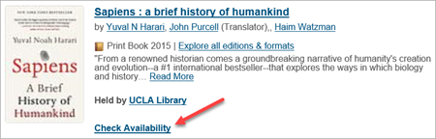
- Item Availability
Melvyl operates with your campus catalog in order to provide real-time item availability information.
  - Advanced Search
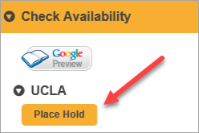
Click the Check Availability link in the brief results display or on the full record display for information.
  - Place Hold
For items that are not available, some campus Melvyl versions display a Place Hold button on the full record. Clicking the button links you to your campus catalog where you can complete the ‘Place Hold’ request.
  - Request
If the print item is not available at your campus, you can request it via Interlibrary Loan (ILL) services by clicking the Request button on the full record.

- Online Availability
Melvyl works with UC-eLinks to provide access to electronic content including articles.
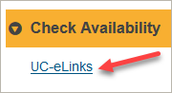
To see if the full text of an article is available, click the UC-eLinks link that displays under the Check Availability section of the full record. If the article is avaialble electronically, you’ll see links to the full text of the article under the Get It Online From section of the UC-eLinks menu. If the article isn’t available electronically, you’ll see options to check the library catalog to see if the article is available from the print journal issue. Or, you can request the article via Interlibrary Loan (ILL) services.

- Personal Lists
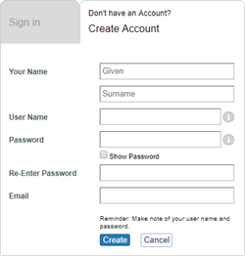
To save items into a personal list, click the Sign In button at the top, right of the Melvyl home page. On the subsequent screen, click the Create Account link and fill in the information requested. Then, click the Create button at the bottom of the form. Once successfully logged into your Melvyl account, the Sign In button at the top of the screen changes to the given name provided. Note: Your Melvyl account works only in the specific campus instance in which it was created.

  - Creating & Saving to a Personal List
- Search for the items you want to include in a list.
- Click the Save button to add the citation to the list.
- When finished, click My Items in the upper right corner to display the list.
- Click on the Create List button.
- Provide a List Name (required) and List Description (optional).
- Select a Privacy preference.
  - Shared: A permalink is generated for others to view, cite and share the list. Changes to the list are updated in real time after the page is refreshed.
  - Private: The default value, no permalink is created and the list is only visible to its creator.
- Click Save.

3 May 2019, jad

