OCLC The Future is Mobile: Is Your Library Ready?
http://www.oclc.org/innovation/default.htm
Intro
“A strong mobile strategy is fundamental to librarians and librarianship” (9:18)
“Traditional catalog-based services are connecting most strongly with ages 55 and older, and sometimes 65 and older” (11:50)
Apps that use library catalog data:
- RedLaser--camera
- pic2shop--camera
- Book Bazaar—location aware
- Text a Librarian (by Mosio)
- WorldCat Mobile Pilot (by Boopsie, for an Web enabled phone)

Lindsay Notwell, Verizon
Future of mobile internet is 4G; will be much faster and streaming video will be common. Will start rollout in next year
“Your patrons are going mobile. These devices are not just phones. These are powerful, mini computers that more and more everyone, and especially this younger generation, this is their computer.” “You need to be mobile because your patrons are going to be mobile”

Sarah Allen, Blazing Cloud
Variety of smartphones with different platforms/languages
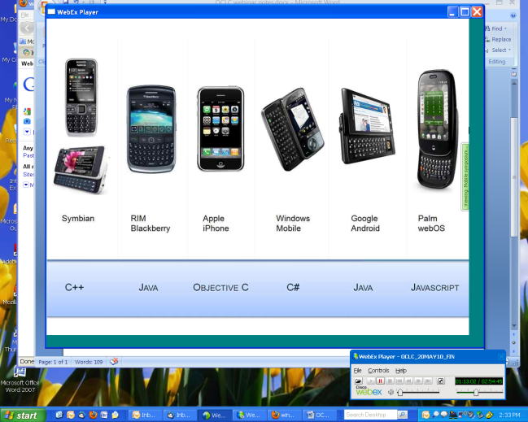

What will it take for people to see mobile as an access point for libraries? “All it will take is one great app. Of course I think it will take a lot of apps before we come up with the one great app.”
create a uniform API for your data (1:37). “Easy enough to change the format on an API. It’s hard to take a mass of data and annotate it. Focus on surfacing the information in a way that can be mined, that can be accessed from a bunch of different angles”
“focus on content that is readable by everybody and then an application that wraps it up”
How can we use mobile context to expose special collection data? Relevant to locale, papers that you’ve read that are relevant to your search

Jack Mason, IBM
Nielsen report about smartphone ownership: half of all Americans by 2011 (find report)
Google Goggles: recognizes text and patterns through camera

