WorldCat Availibilty Query service Overview
The WorldCat Availability Query Service (AQ) works with Request to provide holdings and availability information identify possible UC holdings. The information is intended for ILL staff and interested public services staff.
The AQ service provides holdings and availability information for any OpenURLs that are passed to Request, most typically: Melvyl, UC-elinks, and Primo.
Instructions on how to view the information passed to Request in an OpenURL are included to aid understanding why some bibliographic information may not be passed into VDX.

What Request does when it gets an OURL
The bibliographic information in the OpenURL is the only information Request has to pass to VDX.

Request User Interface
Request parses the OpenURL into the component bibliographic fields for user review; collects enduser account information and passes this to Cameron Patron Service which then validates the user against home campus patron database.
If the patron has not already encountered UC-eLinks, Request will display any electronic links from UC-eLinks (SFX) and an option to forgo the electronic link and continue the ILL request.

Check for UC Holdings Using an OCLC number
Databases that might provide OCLC numbers in an OpenURL include Melvyl (WCD), some FirstSearch databases, and some Primo instances. The AQ services searches the OCLC WorldCat database limited to only items held by UC using the OCLC number index.

If no UC holdings are found using an OCLC number, Request will use the ISxN provided in the OURL.
If there is no ISxN in the OURL, then the request is sent in with no UC holdings.

Check for UC holdings using ISxN
ISxN matching is done in the OCLC WorldCat database limited to only items held by UC, using the ISSN index for ISSNs and the ISBN index for ISBNs.

If no UC holdings are found, then the request will be sent to VDX with no UC holdings.

check for UC Holdings Using available bib data
If the OURL does not contain either an OCLC number or ISxN, Request will send all bibliographic from the OpenURL to the OCLC AQ service. The AQ service will then use OCLC’s “Best Match” algorithm to find UC holdings. This search is most likely based on a title match using the contents of the jtitle (journal title) or btitle (book title) of the OpenURL.
OCLC will match on truncated titles or titles that differ by a single word. This may cause incorrect matches.

monographic series
Each OCLC WorldCat record returned by AQ service is tested if it is a monographic series. For any serials or monographs identified as a whole or part monographic series, AQ will search for UC holdings for its counterpart.
starting from a Matched SERIAL record for an item with A Mono-series indicator
Fields used for matching:
ISSN from 022$a plus volume number from the 440$v 830$v or 490$v volume or
  - Use the contents of the 022$a in the serial to match to the 440$x, 830$x or 490$x (in this order) of the monographic record
If no ISSN Title plus volume from the 440$v 830$v or 490$v volume
  - AQ uses the title 245$a, or 245$a$b in serial item to match to the title 440$a, 830$a, or 490$a in the series title. If no 245 or 246 the 210 $a (abbreviated title) if present is used for matching
starting from a Monograph record with a Mono-series indicator
- ISSN for the series in the 440$x, 830$x or 490$x (in this order) is used for matching to the serial record’s ISSN in the 022$a
- If no ISSN the series title in the 440$a, 830$a or 490$a is used to match to the serial record’s title in the 245$a ( whole item title) or the 246 $a (whole item variant title)
- 440$v 830$v or 490$v is volume number this is not used for matching
Note: OCLC will match on truncated titles or titles that differ by a single word. This may cause incorrect matches.

Filtering and sorting UC holdings
Before sending to VDX, UC holdings are filtered and sorted.
UC holdings are filtered to exclude:
- electronic holdings
- any locations not eligible for lending through ILL
- any items identified as being ‘not available’ (eg. checked out)
- any serial holdings that do not match the year of the item requested

The remaining holdings are ordered based on their geographic group (northern or southern) :
- the closest RLF
- the farther RLF
- load balance of closest geographic group
- load balance of farther geographic group
Along with the bibliographic information from the OURL, the following information is also sent to VDX:
- the patron’s information from the local campus database
- the library name where the holding was found
- the call number of the holding found.

Appendix I Interpreting OpenURLs
The bibliographic data in the OpenURL is the only data included in the VDX record.
The quality of the OpenURL determines the quality of the VDX bibliographic record.
This section shows how to identify the key information in an OpenURL sent to Request from Melvyl or from another OURL source.
Two examples for the same item follow one from an Melvyl record and one for the same item in an A&I database. The item is part of a monographic series.

Melvyl Record for a volume in a monographic series
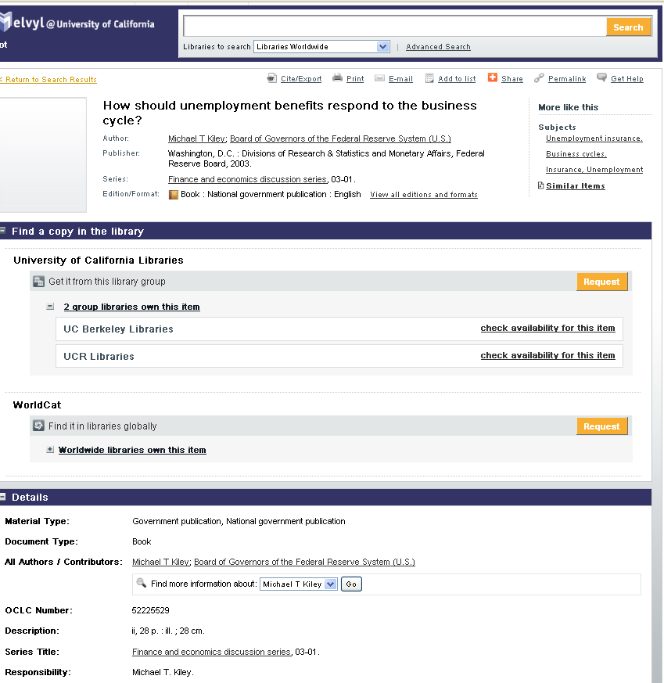

Monographic Series Title

Monographic Series Title

Sample OpenURL Sent to Request by WCD for Item in monoseries
The OpenURL contains all of the information sent to the Request service. Request passes all of this information to VDX. You can copy the OpenURL from the navigation box of the Request form page and paste it into a Word document to see the bibliographic information being passed from the catalog.

https://request.cdlib.org/r2/openurl?url_ver=Z39.88-2004&rfr_id=info%3Asid%2Fmelvyl.worldcat.org%3Aworldcat&rft_val_fmt=info%3Aofi%2Ffmt%3Akev%3Amtx%3Abook&rft.genre=book&rft.genre=book&rft_id=info%3Aoclcnum%2F52225529&rft.aulast=Kiley&rft.aufirst=Michael&rft.btitle=How+should+unemployment+benefits+respond+to+the+business+cycle%3F&rft.date=2003&rft.aucorp=Board+of+Governors+of+the+Federal+Reserve+System+%28U.S.%29&rft.place=Washington++D.C.&rft.pub=Divisions+of+Research+%26+Statistics+and+Monetary+Affairs++Federal+Reserve+Board&rft.identifier=HD7095.U5+K56+2003&rft_dat=%7B%22stdrt1%22%3A%22Book%22%2C%22stdrt2%22%3A%22PrintBook%22%7D&req_id=info:rfa/oclc/institutions/5683&req_dat=&rfe_dat=52225529
To make the OpenURL easier to read: Paste the OpenURL from the navigation box on the Request form page into MS Word. Replace the ampersand (&) with ^p&
https://request.cdlib.org/r2/openurl?url_ver=Z39.88-2004
&rfr_id=info%3Asid%2Fmelvyl.worldcat.org%3Aworldcat
&rft_val_fmt=info%3Aofi%2Ffmt%3Akev%3Amtx%3Abook
&req_dat=%3Csessionid%3E
&rfe_dat=%3Caccessionnumber%3E52225529%3C%2Faccessionnumber%3E
&rft_id=info%3Aoclcnum%2F52225529
&rft.aulast=Kiley
&rft.aufirst=Michael
&rft.auinitm=T
&rft.btitle=How+should+unemployment+benefits+respond+to+the+business+cycle%3F
&rft.date=2003
&rft.aucorp=Board+of+Governors+of+the+Federal+Reserve+System+%28U.S.%29
&rft.place=Washington++D.C.
&rft.pub=Divisions+of+Research+%26+Statistics+and+Monetary+Affairs++Federal+Reserve+Board
&rft.genre=book
&rft.identifier=HD7095.U5+K56+2003
&req_id=info%3Arfa%2Foclc%2FInstitutions%2F5683
OCLC passed this Item to Request as a book. the series information is not included in the OpenURL.
VDX record

Web
--snip---

EBSCOHost Business Source Complete database
Looking for the same item in a licensed database
EBSCOHost Business Source Complete passed this as an article with the series title in the OpenURL.
https://request.cdlib.org:4502/r2/openurl?rft_val_fmt=info%3Aofi%2Ffmt%3Akev%3Amtx%3A&linktype=openurl&rft.auinit1=M&rfr_id=info%3Asid%2FEBSCO%3ABusiness+Source+Complete%3A20919152(Via+SFX)&rft.aulast=Kiley&rft.epage=30&rft.auinit=M+T&rft.atitle=How+Should+Unemployment+Benefits+Respond+to+the+Business+Cycle%3F&rft.date=20030101&rft.month=1&rft.genre=bookitem&rft.spage=1&rft.auinitm=T&rft.btitle=Working+Papers+--+U.S.+Federal+Reserve+Board%5C\'s+Finance&rft.aufirst=Michael',
To make the OpenURL easier to read: Paste the OpenURL from the navigation box on the Request form page into MS Word. Replace the ampersand (&) with ^p&
The OpenURL passed from UC-eLinks to Request
https://request.cdlib.org:4502/r2/openurl?rft_val_fmt=info%3Aofi%2Ffmt%3Akev%3Amtx%3A
&linktype=openurl
&rft.auinit1=M
&rfr_id=info%3Asid%2FEBSCO%3ABusiness+Source+Complete%3A20919152(Via+SFX)
&rft.aulast=Kiley
&rft.epage=30
&rft.auinit=M+T
&rft.atitle=How+Should+Unemployment+Benefits+Respond+to+the+Business+Cycle%3F
&rft.date=20030101
&rft.month=1
&rft.genre=bookitem
&rft.spage=1
&rft.auinitm=T
&rft.btitle=Working+Papers+--+U.S.+Federal+Reserve+Board%5C\'s+Finance
&rft.aufirst=Michael',
VDX record
Web
Change from OTHER TO “Part of Book” to see details

