Center for Research Libraries (CRL) Records now more prominent in NGM
From the inception of the Next Generation Melvyl (NGM) Pilot, the University of California libraries have wanted to display Center for Research Libraries (CRL) records as part of the UC collection. CDL, CRL, and OCLC have worked together to do just that. We are pleased to announce that as of April 13, 2011, CRL records now display in NGM along with the University California Libraries at level 2, even when CRL is the only library holding a particular work.
The inclusion of CRL’s records as part of the University of California Libraries represents an important milestone because it proves the concept that records from a UC “affiliated” library can display as part of the UC collection.
The Center for Research Libraries (CRL) collects and loans unique and little-known humanities, science and social science documents to libraries throughout the world. Eight of ten UC libraries are members of CRL. Membership allows unlimited access to a collection of approximately five million items, including the largest circulating collection of newspapers in North America, more than 38,000 foreign journals and 800,000 foreign dissertations rarely held in U.S. libraries, and major microfilm and paper collections from Africa, Latin America, the Middle East, Europe, South Asia, Southeast Asia, as well as a variety of other benefits.
For many of the CRL records, CRL will be the only library holding a particular work. In that case, the record will display under University of California Libraries.
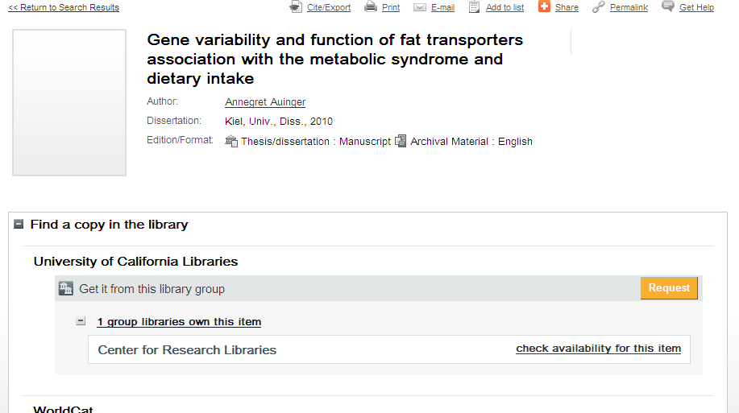

When an item is held by one or more UC libraries as well as by CRL, CRL records appear first because the names of the libraries in NGM file alphabetically. CRL records will also continue to appear in the Libraries worldwide section as a standalone library.

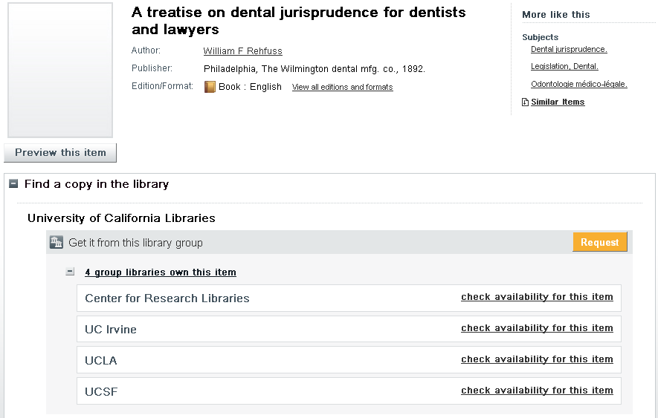

If you encounter any problems or have questions, please use the NGM feedback link to report them.

